Implementation of an Automated Irrigation System

Smart Irrigation system

*by*

U N V P Rajendranath

Dr V. Berlin Hency

The aim of this paper was to make an automated irrigation system using a DHT11 sensor and a VH400 and connect them to an Arduino Uno. This system can interact over a cloud as it will also feature a SIM900A module that will provide it internet access to connect to the cloud.

The main goal is to reduce limit the water content to the most needed areas and reduce the water demand of the farmer which will help him a lot during periods of low rainfall, to help we are using a soil moisture sensor to detect the areas.

Different methods of irrigation studied here

1. Drip Irrigation

Here irrigation is done by water drops which are discharged to the plants’ roots to minimize water wastage and this makes it the most effective irrigation method.

1. Sprinkler system

It uses sprinklers, sprays and guns at end of tubes to irrigate farmlands. It activates only when temperature and humidity reaches a particular threshold value.

Rotary systems are the best sprinkler methods as it throws water in a circular motion and can reach distances of about 100 feets

Proposed work

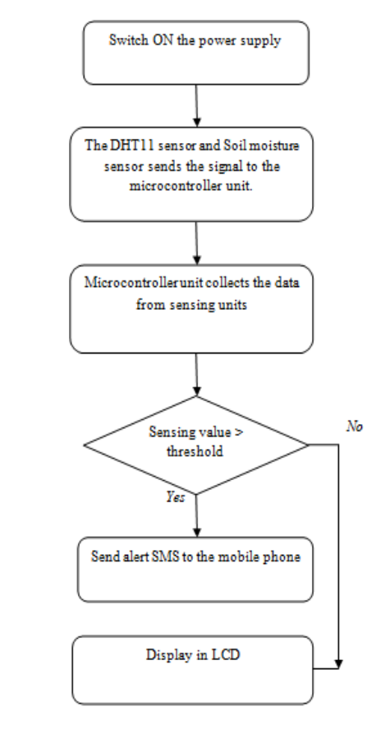

The DHT11 & soli sensor senses the temperature and humidity in the root zone of the plants. The microcontroller unit's principal function is to check the data values sent by sensors and analyse with a predefined threshold. . Whenever it is greater than the threshold value then the microcontroller unit sends the alert SMS to the mobile phone of an owner who is in the remote area.

It contains two units:

1. Control Unit

It consists of a microcontroller (ATMEGA328) which controls the execution of different sensors. Everything is inyefaced through arduino board.

1. Sensing unit

The sensing unit consists of soil and moisture sensor which sends signal every 5 minutes to CU and CU sends message on basis of threshold using SIM900.

1. Soil moisture sensor

It comprises a soil moisture sensor and a LM393 comparator chip. When the soil moisture is LOW, the module output is HIGH, which is indicated by a RED led on the comparator chip. It is a dual output sensor with an analog output mode for better accuracy. It measures the dielectric constant of the soil using transmission line techniques.

Max operating voltage: 5V.

1. B. DHT11 sensor

It takes the temperature and humidity of root of plant. It has three pins : power, ground and data pin. It has high reliability and stability

Results and expansion

This system works very good and can be expanded further by using WSN nodes to transmit data.